**CHAPTER 1**

**INTRODUCTION**

* 1. **INTRODUCTION TO PROJECT**

In today's digitally driven world, the "Campus Navigator" mobile application, a cutting-edge solution meticulously crafted to revolutionize navigation within campus environments. With a primary focus on streamlining processes, it caters to the diverse needs of students, faculty, and staff members. By offering four distinct functionalities, including bus pass requests, concession card management, faculty communication, and faculty vehicle bookings, the app aims to enhance efficiency and convenience.

At its core, the "Campus Navigator" seeks to streamline various campus-related processes. Firstly, it simplifies the process of acquiring bus passes by eliminating the hassle of traditional paper-based systems, allowing users to effortlessly request and obtain digital passes. Secondly, managing concession cards is made seamless through intuitive features, enabling users to apply for cards, manage renewals, and access digital copies with ease. Moreover, the app facilitates effective communication between faculty members and students, providing a dedicated channel for inquiries, announcements, and feedback, thereby fostering collaboration and enhancing academic engagement within the campus community. Lastly, enhancing productivity for faculty members, the app offers a hassle-free solution for booking campus vehicles for official purposes, ensuring efficient utilization of campus resources.

By transitioning from traditional paper-based systems to digital and contactless solutions, the "Campus Navigator" not only enhances operational efficiency but also prioritizes sustainability and environmental stewardship. With its user-centric design and robust functionality, the app sets a new standard for campus navigation applications, promising a seamless and enriching experience for all users within the campus ecosystem.

Traversing the intricate pathways of a university campus has historically been fraught with complexities, often compounded by outdated paper-based systems governing essential services such as bus passes and concession cards. However, the advent of the "Campus Navigator" marks a watershed moment in this narrative, heralding a paradigm shift towards digital and contactless solutions. Embracing the cutting edge of technology, this transformative application endeavors to reimagine the navigation experience, placing paramount emphasis on convenience, security, and efficacy.

At the core of the "Campus Navigator" lies an unwavering dedication to ushering in a new era of digital transformation within campus navigation. By boldly transitioning away from antiquated paper-based systems to sleek, efficient digital and contactless solutions, the application not only modernizes but revolutionizes how individuals navigate their academic environments. This paradigm shift isn't just about embracing the latest technology; it's about fundamentally reimagining the entire navigation experience to better serve the diverse needs of students, faculty, and staff while fostering a more sustainable campus ecosystem.

Gone are the days of fumbling with physical bus passes or worrying about their loss or damage. With the "Campus Navigator," users now have the power to seamlessly purchase, manage, and validate their passes directly within the app's intuitive interface. This not only eliminates the hassle of carrying around physical passes but also streamlines interactions with college transport authorities. Real-time updates and notifications ensure users are always informed about bus schedules, delays, or route changes, providing a level of convenience and peace of mind previously unseen in campus transit systems.

Similarly, the digitization of concession card services represents a monumental leap forward in accessibility and convenience. No longer constrained by cumbersome paperwork or long wait times, users can effortlessly apply for and download digital copies of their concession cards with just a few taps on their smartphones. Whether it's accessing campus facilities, purchasing meals, or availing of student discounts, the "Campus Navigator" puts the power of these essential services directly into the hands of its users, ensuring seamless access and inclusivity for all members of the campus community.

Yet, the benefits of digital transformation extend far beyond mere convenience. By reducing reliance on paper-based systems, the "Campus Navigator" also contributes to a more sustainable campus environment. The reduction in paper usage not only minimizes waste but also lowers the carbon footprint associated with traditional printing processes. In an era where environmental sustainability is of paramount importance, the "Campus Navigator" sets a shining example of how technological innovation can be harnessed to create positive change and promote eco-conscious practices within educational institutions.

In essence, the "Campus Navigator" isn't just a mobile application; it's a catalyst for change, a beacon of progress in the ever-evolving landscape of campus navigation. By embracing digital transformation and leveraging cutting-edge technology, it not only enhances the user experience but also drives efficiency, accessibility, and sustainability across the entire campus ecosystem. As we stand on the precipice of a new era in education, the "Campus Navigator" stands ready to lead the way, guiding students, faculty, and staff toward a future where navigating campus life is not just effortless but truly empowering.

In summary, the "Campus Navigator" mobile application represents a transformative leap in campus navigation, signaling the dawn of a new era characterized by digital efficiency, unparalleled convenience, and sustainable practices. By embracing the possibilities afforded by digital transformation and leveraging innovative technologies, this application not only optimizes navigation processes but also enhances productivity and user experience across the entire campus community.

Through its intuitive interface and robust features, the "Campus Navigator" streamlines the complexities of navigating campus environments, offering real-time updates, optimized routes, and seamless integration with campus services. By replacing outdated paper-based systems with digital alternatives, the application not only reduces environmental impact but also simplifies interactions, empowering users to effortlessly manage their transportation needs and access campus facilities.

As educational institutions continue to adapt to the demands of the digital age, the "Campus Navigator" stands as a beacon of progress, guiding users towards a future where navigation is intuitive, efficient, and environmentally conscious.

* 1. **SCOPE**

The "Campus Navigator" mobile application revolutionizes campus navigation and administrative processes, catering to the diverse needs of students, faculty, and staff within the college environment. With a focus on seamless digital experiences and efficient service delivery, the app offers a comprehensive solution to streamline campus navigation, manage administrative tasks, and facilitate communication within the campus community.

* **Efficient Campus Navigation**: Provide users with accurate maps, directions, and information about campus buildings, facilities, and amenities for easy navigation.
* **Digital Transformation of Services**: Transition traditional paper-based processes to digital and contactless solutions to enhance convenience and streamline administrative tasks.
* **Bus Pass Requests and Payment:** Users can request bus passes through the app and securely complete transactions for payment within the application. This eliminates the need for physical passes and simplifies the process for both users and college transport authorities.
* **Concession Card Management with PDF Download Option**: Users can manage concession cards digitally through the app, including applying for new cards, renewing existing ones, and downloading PDF copies for convenience.
* **Communication with Faculty:** Provide a platform for users to communicate with faculty members, fostering collaboration and support within the campus community.
* **Faculty Vehicle Bookings:** Faculty members can conveniently book campus vehicles for official purposes through the app, enhancing productivity and streamlining administrative tasks.
  1. **OBJECTIVES**

The objectives of the Campus Navigator project are :

* Efficient Campus Navigation:

Provide users with interactive maps that display campus buildings, facilities, parking lots, and other points of interest.Include features such as search functionality, indoor navigation, and real-time updates on building accessibility or closures.Offer personalized route recommendations based on user preferences, such as shortest path, wheelchair accessibility, or avoiding stairs.

* Digital Transformation of Services:

Digitize existing paper-based processes to streamline administrative tasks and reduce paperwork.Implement secure authentication and data encryption protocols to ensure the confidentiality and integrity of user information.Integrate with existing college systems, such as student databases and transportation management systems, to synchronize data and processes seamlessly.

* Bus Pass Requests and Payment:

Allow users to request and purchase bus passes directly within the app using secure payment methods, such as credit/debit cards or mobile wallets.

Provide users with options for single-use or recurring passes, with automatic renewal features for added convenience.Generate digital passes within the app that can be easily validated by bus drivers or transport authorities.

* Concession Card Management with PDF Download Option:

Enable users to apply for new concession cards, renew existing ones, or report lost/stolen cards through the app.Offer the option to download PDF copies of concession cards, which can be stored digitally on users' devices or printed for physical use.Implement secure verification mechanisms to prevent unauthorized access to concession card information and ensure data privacy.

* Communication with Faculty:

Implement a messaging platform for direct communication between students and faculty members, including Heads of Department (HoDs) and tutors. Enable students to request transportation services for events like industrial visits (IVs) and placements, schedule academic assistance appointments, and engage in group discussions.

* Faculty Vehicle Bookings:

Offer a dedicated booking portal for faculty members to reserve campus vehicles for official use, such as attending conferences, conducting research, or supervising field trips.

Display vehicle availability in real-time, Integrate with the college's vehicle fleet management system to track vehicle usage, maintenance schedules, and fuel consumption for reporting and optimization purposes.

* Addressing Ethical Considerations

The project places a strong emphasis on addressing ethical considerations related to AI-generated content, such as ensuring fairness, transparency, and privacy. This includes addressing biases in training data, providing clear explanations of how the system works, and safeguarding user data and privacy.

* Promoting Inclusivity and Diversity

Visual Vocabulary aims to promote inclusivity and diversity by designing a system that caters to users from diverse backgrounds and demographics. This includes considering the needs and preferences of users with disabilities, language barriers, and other accessibility challenges.

* Fostering Collaboration and Knowledge Sharing

The project aims to foster collaboration and knowledge sharing among researchers, developers, and users in the field of AI-driven multimedia processing. This includes collaborating with academic and industry partners, sharing research findings and insights, and engaging with the broader community through conferences, workshops, and publications.

* Creating Impactful and Meaningful Solutions

Ultimately, the objective of Visual Vocabulary is to create impactful and meaningful solutions that have real-world applications and benefits. This includes developing technologies that empower users, enhance communication and understanding, and contribute to positive social and economic outcomes.

**CHAPTER 2**

**PROOF OF WORK**

**2.1 INTRODUCTION**

Text-to-image Diffusion Models in Generative AI A Survey: This survey provides an overview of text-to-image diffusion models, exploring their rising prominence in generative tasks. It begins by explaining the foundational workings of diffusion models for image synthesis and the impact of conditioning on learning within these models. Subsequently, it delves into a review of state-of-the-art methods for text-conditioned image synthesis, elucidating various approaches and techniques proposed in the literature. Each method is critically assessed, highlighting strengths, limitations, and potential applications. Ultimately, the survey offers valuable insights into the evolving landscape of text-to-image synthesis using diffusion models, paving the way for future advancements in generative AI. [1]

Text to image generation using Stable Diffusion : Diffusion models (DMs) offer cutting-edge image synthesis by sequentially applying denoising autoencoders, but their pixel-based operation requires extensive GPU resources and costly inference. Leveraging latent spaces of pretrained autoencoders, we enable DM training on constrained resources while maintaining quality. Incorporating cross-attention layers transforms DMs into versatile generators, accommodating inputs like text or bounding boxes for high-resolution synthesis. Latent diffusion models (LDMs) achieve exceptional performance across tasks like text-to-image synthesis.[2]

Text to image generation using Stable Diffusion Technology : The text-to-image conversion task has historically posed challenges in computer vision, but recent advancements in generative models have spurred the development of various synthesis techniques. This project focuses on leveraging the Stable Diffusion framework for text-to-image synthesis, a diffusion-based generative model known for producing high-quality, detailed images. Introducing a novel approach, the project entails learning a joint embedding space for text and image domains to enable the Stable Diffusion model to generate realistic images aligned with textual descriptions.[3]

Image Caption Generator using Deep Learning :This project introduces a deep learning-based image caption generator that utilizes convolutional neural networks (CNNs) and Long Short-Term Memory (LSTM) models. The CNN model identifies objects within input images, while the LSTM model generates descriptive captions summarizing the content. By leveraging these algorithms, the proposed model focuses on accurately identifying objects and generating suitable titles for input images, thereby enhancing the understanding and interpretation of visual content.[4]

Image Description using Visual Dependency Representations :Traditional approaches to describing images have often represented them as unstructured bags of regions, hindering accurate prediction of meaningful relationships between objects. In this paper, visual dependency representations are introduced to capture these relationships and improve image description. Two template-based description generation models are proposed, operating over these representations. Evaluating on a new dataset of region-annotated images, results show that these models outperform previous approaches relying on object proximity or corpus information, both in automatic measures and human judgements, thus demonstrating the efficacy of visual dependency representations in enhancing image description tasks. [5]

Show and Tell: A Neural Image Caption Generator : This paper presents a generative model leveraging a deep recurrent architecture that combines advancements in computer vision and machine translation to automatically describe image content using natural language. The model is trained to maximize the likelihood of target description sentences given training images. Experimental results across multiple datasets demonstrate the accuracy and fluency of the model's generated language solely from image descriptions. Notably, the proposed approach achieves significant improvements over state-of-the-art BLEU-1 scores, such as 59 on Pascal (compared to 25), 66 on Flickr30k (compared to 56), 28 on SBU (compared to 19), and a BLEU-4 of 27.7 on COCO, establishing new benchmarks in image description tasks.[6]

**2.2 EXISTING SYSTEM**

The existing text-to-image generation landscape predominantly relies on Generative Adversarial Networks (GANs) as the cornerstone technology. GAN-based systems are at the forefront of generating realistic images from textual descriptions, revolutionizing the intersection of natural language processing and computer vision. However, the widespread adoption of GANs in text-to-image generation is accompanied by several inherent challenges.

* Mode Collapse: GANs are prone to mode collapse, where the generator produces limited variations of the target distribution, resulting in repetitive or incomplete outputs.
* Training Instability: GAN training can be unstable due to vanishing gradients or oscillations, requiring careful hyperparameter tuning and regularization techniques to achieve convergence and high-quality results.
* Evaluation Challenges: Assessing the quality and diversity of generated images is difficult, as traditional evaluation metrics may not fully capture perceptual quality or semantic relevance, necessitating additional subjective evaluations or human judgments.
* Need for Large Datasets: GANs often require large datasets to learn meaningful image representations and capture the variability present in the data distribution. Limited or biased training data can negatively impact the performance and generalization ability of GAN-based models, leading to suboptimal results.
* Evaluation Challenges: Assessing the quality and diversity of generated images produced by GANs can be challenging. Traditional evaluation metrics may not fully capture the perceptual quality or semantic relevance of generated images, requiring additional subjective evaluations or human judgments.

The existing image caption generation relies on Bag-of-Words(BoW) and k-nearest neighbors (KNN) approach. The Bag-of-Words (BoW) and k-nearest neighbors (KNN) approach for image captioning has several disadvantages:

* Limited Semantic Understanding: BoW representations treat images as unordered collections of visual features, ignoring spatial relationships and semantic context. This simplistic representation may lead to captions that lack coherence and fail to capture the semantics of the image.
* Curse of Dimensionality: Representing images as high-dimensional BoW vectors can lead to the curse of dimensionality, where the distance between data points becomes less meaningful in high-dimensional spaces. This can result in suboptimal performance and scalability issues, especially as the number of features increases.
* Dependence on Handcrafted Features: The performance of BoW and KNN-based image captioning heavily relies on the quality and relevance of handcrafted features. Designing effective feature extractors requires domain expertise and may not capture all relevant information present in the image.
* Limited Generalization: KNN-based methods rely on finding similar images in the training set to generate captions. This limits their ability to generalize to unseen or novel images that may not have close matches in the training data, leading to poor performance on out-of-distribution images.
* High Computational Cost: KNN requires computing distances between the query image and all images in the training set, which can be computationally expensive, especially for large datasets. This high computational cost may limit the scalability of the approach to real-world applications.

**2.3 PROPOSED SYSTEM**

The proposed system of text to image generation uses Stable diffusion technique. The advantages of using such systems are:

* High-Quality Outputs: Stable diffusion models are known for producing high-quality, realistic images with fine details and textures. By leveraging diffusion techniques, these models can capture complex patterns and structures in the generated images, resulting in visually appealing outputs.
* Stable Training: Stable diffusion models offer a stable training process, making them easier to train compared to other generative models like GANs. This stability reduces the likelihood of mode collapse or training instabilities, leading to more reliable and consistent performance.
* Scalability: Stable diffusion models can handle large-scale datasets and high-resolution images efficiently. This scalability makes them suitable for generating images with varying levels of complexity and detail, accommodating a wide range of applications and use cases.
* Generated Image Download Option: Allowing users to download generated images provides them with convenient access to the output of the system, enabling easy sharing and usage for various purposes such as social media, presentations, or personal collections.
* Voice Input: Voice input enhances system accessibility by enabling users to interact with the text-to-image generation functionality using natural language spoken commands, making the system more inclusive and user-friendly. Voice input simplifies the user experience by eliminating the need for manual text input, particularly beneficial in scenarios where typing may be cumbersome or inconvenient, thereby enhancing overall user satisfaction and efficiency.

The integration of Convolutional Neural Networks (CNNs) and Long Short-Term Memory (LSTM) networks has revolutionized the field of image caption generation, offering a robust framework for generating descriptive and contextually relevant captions for images. Some of them are :

* Effective Feature Extraction: CNNs excel at extracting rich visual features from images, providing essential semantic information necessary for descriptive caption generation.
* Semantic Understanding and Contextual Relevance: By integrating LSTM networks, the model can understand semantic relationships between visual features and caption words, ensuring contextually relevant and coherent captions.
* Adaptability to Image Complexity: LSTM networks' capability to produce variable-length outputs allows the model to adapt to varying image complexities, generating captions of appropriate length.
* End-to-End Learning and Scalability: CNN-LSTM architectures enable end-to-end learning, optimizing both feature extraction and caption generation components simultaneously. This scalability facilitates training on large datasets, leading to more accurate and meaningful captions.
* Enhanced User Interaction and Accessibility: Integrating speech synthesis for caption output enhances user accessibility and interaction by providing auditory feedback, making the system inclusive and engaging. This innovation reflects advancements in human-computer interaction, enhancing user satisfaction and convenience.

**CHAPTER 3**

**SYSTEM ANALYSIS AND DESIGN**

**3.1 SYSTEM ANALYSIS**

**3.1.1 INTRODUCTION**

The integration of Stable Diffusion Models, CNN-LSTM architectures, and feature extraction with VGG16 not only facilitates the generation of high-quality images from textual descriptions but also enables the creation of descriptive captions for images, thereby enriching the understanding and accessibility of visual content. This system holds promise across diverse domains, from aiding content creators in generating visual assets to providing visually impaired individuals with enhanced access to digital media. Furthermore, its potential extends to interactive interfaces, where users can seamlessly communicate with machines through a combination of text and images. As we embark on this journey of innovation, our goal is not only to push the boundaries of AI-driven technologies but also to foster a more inclusive and interactive digital landscape, where communication between humans and machines transcends traditional boundaries. Through this project, we aspire to contribute to the ongoing evolution of artificial intelligence, paving the way for a future where technology empowers individuals to express themselves more intuitively and interact with the digital world more seamlessly.

This comprehensive system represents a significant step forward in the convergence of natural language processing and computer vision, showcasing the transformative potential of AI-driven technologies. By seamlessly integrating cutting-edge techniques from both domains, our project aims to bridge the gap between textual descriptions and visual content, offering users a versatile platform for communication and creativity. Through the synthesis of images from text and the generation of descriptive captions for images, our system not only enhances accessibility and understanding but also enriches human-computer interaction experiences across various domains. With its ability to cater to diverse user needs, from content creation to accessibility tools, our system exemplifies the potential of AI to empower individuals and foster inclusive digital environments.

**3.1.2 METHODOLOGY**

Our methodology for developing the text to image generation and image captioning system involves a systematic and iterative approach. We begin with an extensive review of existing research and methodologies in the fields of natural language processing and computer vision to identify state-of-the-art techniques and frameworks. Once the appropriate models and architectures are selected, we collect and preprocess datasets of image-text pairs, ensuring consistency and compatibility with the chosen models. The implementation phase involves developing the system using suitable programming languages and frameworks, with a focus on integrating the text to image generation module using Stable Diffusion Models and the image captioning module with CNN-LSTM and VGG16 feature extraction.

Training and fine-tuning of the models follow, where we optimize performance through iterative training cycles and adjustments of model hyperparameters. Evaluation of the system's performance is conducted rigorously, assessing criteria such as image quality, coherence of generated captions, and accuracy against ground truth annotations. Optimization efforts are then made to improve efficiency, scalability, and resource utilization, ensuring the system meets the desired performance standards. Integration and deployment of the trained models into a unified system architecture precede thorough testing and validation phases, where we verify the correctness, robustness, and reliability of the system under various scenarios. Finally, comprehensive documentation is prepared, detailing the system architecture, implementation specifics, and guidelines for usage and maintenance. This methodology ensures a systematic and thorough approach to developing a highly functional and reliable text to image generation and image captioning system.

Moreover, our methodology emphasizes continuous iteration and improvement throughout the development lifecycle. By adhering to best practices in software development and AI research, we strive to deliver a robust and reliable system that meets the evolving needs of users and stakeholders. This iterative approach not only ensures the success of the current project but also lays the foundation for future advancements and innovations in the field of AI-driven text to image generation and image captioning.

**3.1.3 HARDWARE REQUIREMENTS**

* Processor: A multi-core processor (Intel Core i5 or higher, AMD Ryzen 5 or higher) to handle the computational workload efficiently.
* Memory (RAM): At least 8GB of RAM to support the simultaneous operation of the text-to-image generation and image caption generation modules, as well as any additional software components.
* Graphics Processing Unit (GPU): A dedicated GPU with CUDA support for accelerated training and inference of deep learning models, especially for image processing tasks.
* Storage: Sufficient storage space (at least 256GB SSD) for storing datasets, model checkpoints, and software libraries.
* Microphone: A microphone for capturing voice input for text-to-image generation.
* Speakers or Headphones: Audio output devices such as speakers or headphones for listening to the generated image captions.

**3.1.4 SOFTWARE REQUIREMENTS**

* Operating System : Windows
* Python : Python 3.7 or higher
* Integrated Development Environment (IDE): A Python IDE Visual Studio Code for writing, debugging, and executing code.
* Deep Learning Frameworks: Installation of deep learning frameworks such as TensorFlow and PyTorch
* Speech Recognition Library: Installation of a speech recognition library such as SpeechRecognition for processing voice input for text-to-image generation.
* Text-to-Speech (TTS) Library: Installation of a text-to-speech library such as pyttsx3 for converting generated image captions into audio output.
* Web Development Tools: If developing a web-based interface for user interaction, web development tools such as HTML, CSS, JavaScript, Bootstrap and Flask for backend development.

**3.2 SYSTEM DESIGN**

**3.2.1 INTRODUCTION**

In recent years, the integration of natural language processing (NLP) and computer vision has catalyzed remarkable advancements in artificial intelligence, particularly in the realms of image generation from textual descriptions and vice versa. Our project presents a comprehensive system that leverages state-of-the-art techniques in both domains, featuring Stable Diffusion Models for precise text to image generation and Convolutional Neural Networks (CNNs) coupled with Long Short-Term Memory (LSTM) networks and VGG16 architecture for image captioning and feature extraction. By seamlessly integrating these components, our system offers a robust workflow: users input textual descriptions to generate corresponding images or upload images to receive descriptive captions. This approach holds immense potential for revolutionizing content creation, accessibility, and human-computer interaction, showcasing a significant stride towards more intuitive and expressive communication between humans and machines. With its ability to synthesize images from text and provide detailed captions for images, our system not only facilitates creative expression but also enhances accessibility for visually impaired individuals and augments human-computer interaction experiences across various domains, including education, entertainment, and assistive technologies. Through this project, we aim to contribute to the ongoing advancement of AI-driven technologies, driving innovation and fostering inclusive digital environments.

In summary, our system blends natural language processing and computer vision to create images from text and describe images with text. By combining cutting-edge techniques like Stable Diffusion Models and CNN-LSTM networks with VGG16 feature extraction, we've built a tool that not only facilitates creative expression but also improves accessibility and human-computer interaction. It's a step forward in making technology more intuitive and inclusive, enabling users to communicate more effectively through text and images.

**3.2.2 MODULE DESCRIPTION**

**LOGIN MODULE**

This module facilitates user authentication and access control, ensuring secure access to the text-to-image and image caption generation functionalities.

* Functionality: Users register for accounts, log in with their credentials, and gain access to the system's features. The module includes features for user registration, login, password recovery, and account management.
* Implementation: The module is implemented using web development technologies and interacts with a database to store and retrieve user account information securely.

Key Components:

* User Registration: Allows new users to create accounts by providing necessary information.
* User Authentication: Verifies user credentials during the login process to grant access to system functionalities.
* Password Recovery: Provides functionality for users to reset their passwords if forgotten or lost.
* Integration: Seamlessly integrates with the text-to-image and image caption generation modules, allowing authenticated users to access these functionalities without re-entering credentials.
* Login using Social Platforms: Users have the option to log in using their existing accounts on popular social platforms such as Google, Facebook, or Twitter. This feature streamlines the login process and provides users with additional convenience by eliminating the need to create a separate account. Additionally, it can enhance user engagement and facilitate social sharing of generated content.

These modules collectively form the backbone of your Visual Vocabulary project, providing users with powerful tools for generating and interpreting visual content.

**Text-to-Image Generation Module**

The Text-to-Image Generation Module is a key component of the Visual Vocabulary project, empowering users to convert textual descriptions into visually expressive images. This module incorporates advanced techniques such as stable diffusion for generating high-quality images from text inputs.

* Functionality: Users input text descriptions, and the system generates corresponding images that best represent the described content. The module leverages advanced machine learning techniques, such as stable diffusion, to translate textual descriptions into visual representations.
* Implementation: The module integrates stable diffusion models, which break down the image generation process into sequential steps. These models are trained on large datasets of text-image pairs to learn the complex mappings between text and visual features.

Capabilities of this module:

* Text Input Interface: Provides users with an intuitive interface to input textual descriptions or captions Supports various input methods including manual typing and voice input for convenience and flexibility.
* Stable Diffusion-based Image Generation: Implements stable diffusion models to synthesize realistic images from textual descriptions. Utilizes pre-trained diffusion models to efficiently transform text embeddings into visually coherent images.
* Image Download Option: Enables users to download the generated images directly from the interface. Offers multiple image format options (e.g., JPEG, PNG) for user preference and compatibility.
* Voice Input Integration: Integrates speech recognition technology to accept voice commands as input for text descriptions. Utilizes natural language processing (NLP) techniques to convert voice inputs into text for image generation.

**Image Caption Generation Module**

The Image Caption Generation Module is a crucial component of the Visual Vocabulary project, enabling the system to provide textual interpretations of visual content through descriptive captions. Leveraging Convolutional Neural Networks (CNNs) for image feature extraction and Long Short-Term Memory (LSTM) networks for sequential caption generation, this module enriches user experience by offering insightful textual descriptions of uploaded images.

* Functionality: Users upload images via the interface, prompting the system to generate captions that accurately describe the content and context depicted in the images. The module employs advanced machine learning techniques, specifically CNNs and LSTM networks, to achieve this functionality. CNN models extract rich visual features from the input images, which are subsequently fed into LSTM networks to generate coherent and contextually relevant captions.

Capabilities of this module:

* Image Feature Extraction: Utilizes pre-trained CNN models to extract meaningful visual features from the uploaded images. CNNs analyze the spatial relationships and hierarchical structures within the images to capture relevant visual information.
* Caption Generation: Employs LSTM networks to generate sequential captions based on the extracted image features. LSTM networks excel at processing sequential data, allowing the model to generate captions one word at a time while maintaining contextual coherence.
* Training Pipeline: Fine-tunes the CNN and LSTM models using paired image-caption datasets to optimize caption generation performance. Training involves iterative optimization of model parameters to minimize the discrepancy between generated captions and ground truth captions in the training data.
* Speaking of Generated Caption: Integrates speech synthesis technology to audibly convey the generated captions to users. Enables users to listen to the descriptive captions, providing an additional mode of interaction and accessibility.

**3.2.3 SYSTEM ARCHITECTURE**

**Text to Image Generation**

Stable Diffusion : Large text to image models have achieved remarkable success in enabling high quality synthesis of images from text prompts. Diffusion models can be applied to text to image generation tasks to achieve state of art image generating results. Stable Diffusion model has achieved state of the art results for image generation. Stable Diffusion is based on a particular type of diffusion model called Latent Diffusion model, proposed in High-Resolution Image Synthesis with Latent Diffusion Models and created by the researchers and engineers from CompVis, LMU and RunwayML. The model was initially trained on 512x512 images from a subset of the LAION-5B database. This is particularly achieved by encoding text inputs into latent vectors using pretrained language models like CLIP. Diffusion models can achieve state-of-the-art results for generating image data from texts. But the process of denoising is very slow and consumes a lot of memory when generating high-resolution images. Therefore, it is challenging to train these models and also use them for inference. In this regard, latent diffusion can reduce the memory and computational time by applying the diffusion process over a lower dimensional latent space, instead of using the actual pixel space. In latent diffusion, the model is trained to generate latent (compressed) representations of the images.

Stable Diffusion is a large text to image diffusion model trained on billions of images. Image diffusion model learn to denoise images to generate output images. Stable Diffusion uses latent images encoded from training data as input. Further, given an image zo, the diffusion algorithm progressively add noise to the image and produces a noisy image zt, with t being how many times noise is added. When t is large enough, the image approximates pure noise. Given a set of inputs such as time step t, text prompt, image diffusion algorithms learn a network to predict the noise added to the noisy image zt.

There are mainly three main components in latent diffusion:

* An autoencoder (VAE).
* A U-Net.
* A text-encoder
* The autoencoder (VAE) :

The VAE model has two parts, an encoder and a decoder. During latent diffusion training, the encoder converts a 512*512*3 image into a low dimensional latent representation of image of size say 64*64*4 for the forward diffusion process. We call these small encoded versions of images as latents. We apply more and more noise to these latents at each step of training. This encoded latent representation of images acts as the input to the U-Net model.

Here, we are converting an image of shape (3, 512, 512) into a latent of shape(4, 64, 64), which requires 48 times less memory. This leads to reduced memory and compute requirements compared to pixel-space diffusion models.The decoder transforms the latent representation back into an image. We convert the denoised latents generated by the reverse diffusion process into images using the VAE decoder. During inference, we only need the VAE decoder to convert the denoised image into actual images.

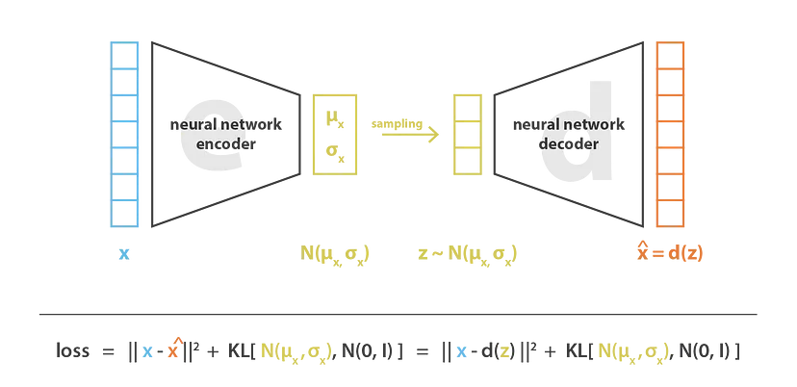

* UNet :

The U-Net predicts denoised image representation of noisy latents. Here, noisy latents act as input to UNet and the output of UNet is noise in the latents. Using this, we are able to get actual latents by subtracting the noise from the noisy latents. The Unet that takes in the noisy latents (x) and predicts the noise. We use a conditional model that also takes in the timestep (t) and our text embedding as guidance. The model is essentially a UNet with an encoder(12 blocks), a middle block and a skip connected decoder(12 blocks). In these 25 blocks, 8 blocks are down sampling or upsampling convolution layer and 17 blocks are main blocks that each contain four resnet layers and two Vision Transformers(ViTs).

Here the encoder compresses an image representation into a lower resolution image representation and the decoder decodes the lower resolution image representation back to the original higher resolution image representation that is supposedly less noisy.

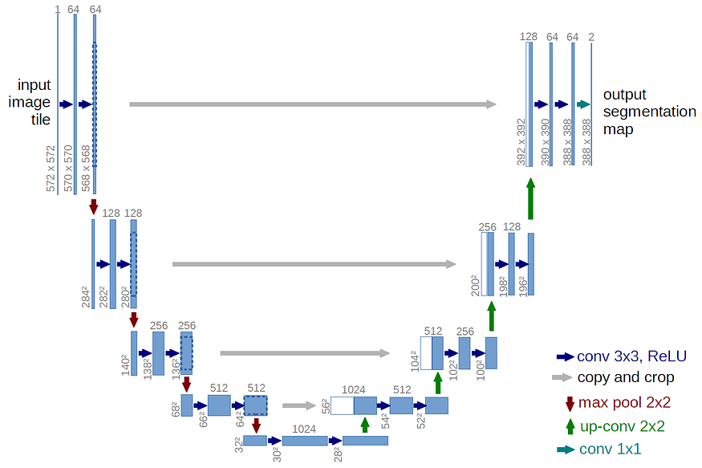

* The Text-encoder :

The text-encoder transforms the input prompt into an embedding space that goes as input to the U-Net. This acts as guidance for noisy latents when we train Unet for its denoising process. The text encoder is usually a simple transformer-based encoder that maps a sequence of input tokens to a sequence of latent text-embeddings. Stable Diffusion does not train a new text encoder and instead uses an already trained text encoder, CLIP. The text encoder creates embeddings corresponding to the input text.

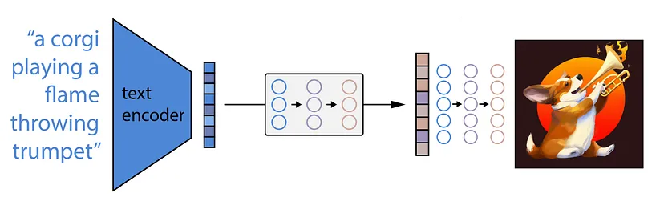

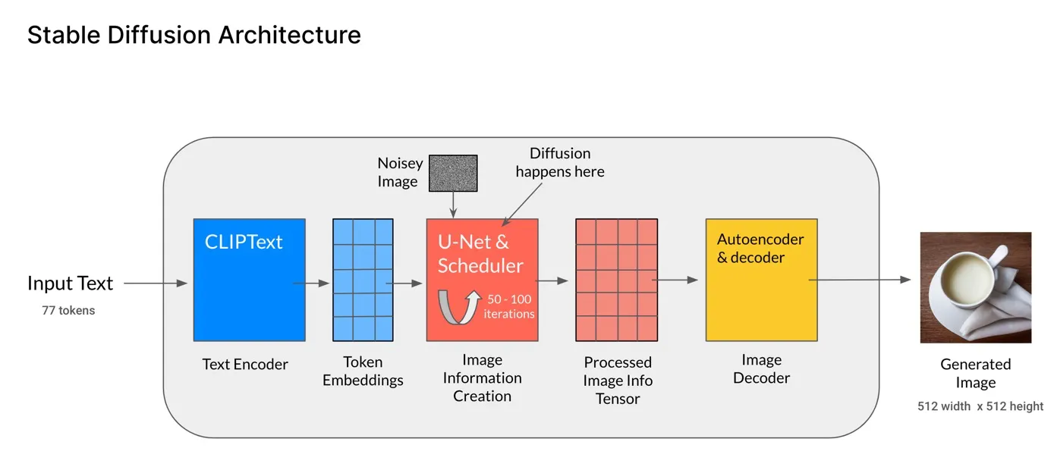

**Stable Diffusion Architecture**

**Image Caption Generation** : Image Caption Generator uses the concepts of natural language processing and computer vision to predict the given image and describe it in the English

like language. This model is developed by two main models of deep learning, i.e. CNN and LSTM(Long Short Term Memory ).

Dataset

The Flickr_8K dataset represents the model training of image caption generators. It is small in size. So, the model can be trained easily on low-end laptops/desktops. Data is properly labelled. For each image 5 captions are provided.

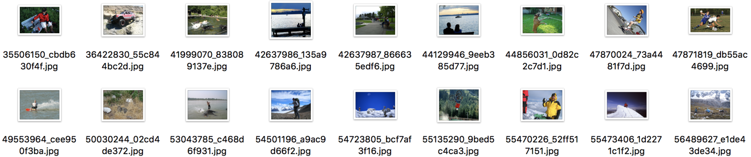

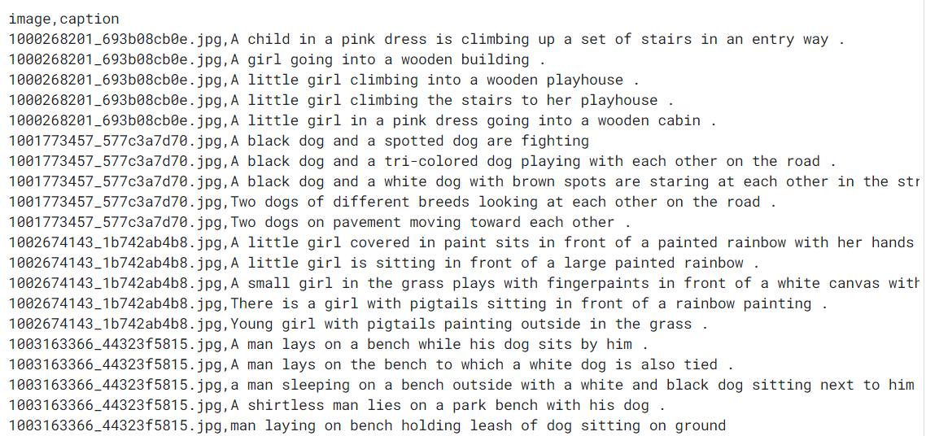

**The Architecture of Network**

1. Image Features Detection

For image Detecting, we are using a pre-trained model which is VGG16. VGG16 is already installed in the Keras library. VGG 16 was proposed by Karen Simonyan and Andrew Zisserman of the Visual Geometry Group Lab of Oxford University in 2014.

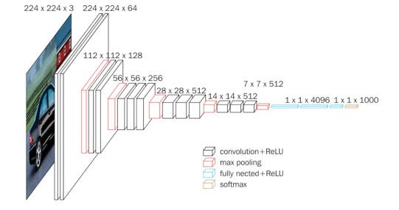

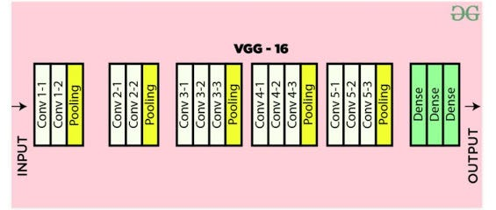

The input to conv1 layer is of fixed size 224 x 224 RGB image. The image is passed through a stack of convolutional (conv.) layers, where the filters were used with a very small receptive field: 3×3 (which is the smallest size to capture the notion of left/right, up/down, center). In one of the configurations, it also utilizes 1×1 convolution filters, which can be seen as a linear transformation of the input channels (followed by non-linearity). The convolution stride is fixed to 1 pixel; the spatial padding of conv. layer input is such that the spatial resolution is preserved after convolution, i.e. the padding is 1-pixel for 3×3 conv. layers. Spatial pooling is carried out by five max-pooling layers, which follow some of the conv. layers (not all the conv. layers are followed by max-pooling). Max-pooling is performed over a 2×2 pixel window, with stride 2.

Three Fully-Connected (FC) layers follow a stack of convolutional layers (which has a different depth in different architectures): the first two have 4096 channels each, the third performs 1000-way ILSVRC classification and thus contains 1000 channels (one for each class). The final layer is the soft-max layer. The configuration of the fully connected layers is the same in all networks.

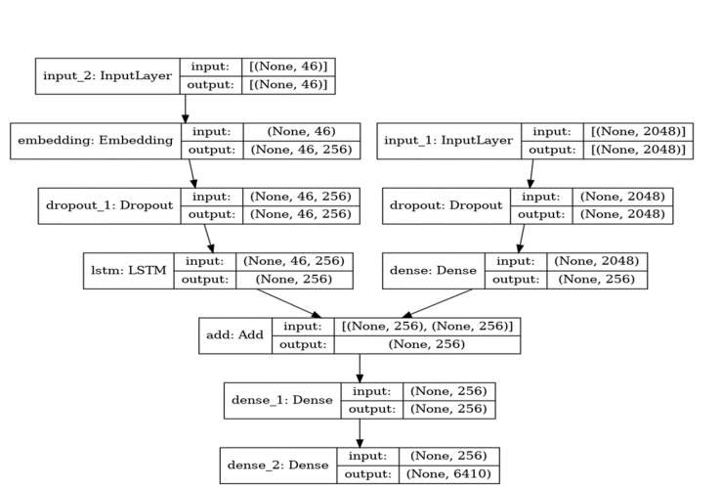

Workflow Diagram

2. Text Generation using LSTM : Long Short Term Memory networks — usually just called “LSTMs” — are a special kind of RNN, capable of learning long-term dependencies. They were introduced by Hochreiter & Schmidhuber (1997) and were refined and popularized by many people in the following work. They work tremendously well on a large variety of problems and are now widely used.

Long Short Term Memory networks — usually just called “LSTMs” — are a special kind of RNN, capable of learning long-term dependencies. They were introduced by Hochreiter & Schmidhuber (1997).

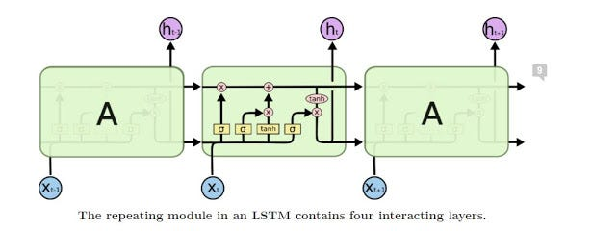

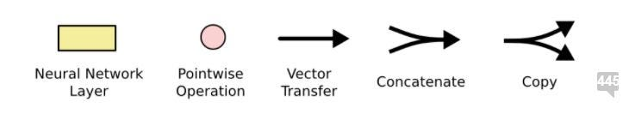

A common LSTM unit is composed of a cell, an input gate, an output gate and a forget gate. The cell remembers values over arbitrary time intervals and the three gates regulate the flow of information into and out of the cell.

LSTM networks are well-suited to classifying, processing, and making predictions based on time series data since there can be lags of unknown duration between important events in a time series. LSTMs were developed to deal with the vanishing gradient problem that can be encountered when training traditional RNNs. Relative insensitivity to gap length is an advantage of LSTM over RNNs, hidden Markov models, and other sequence learning methods in numerous applications.

The advantage of an LSTM cell compared to a common recurrent unit is its cell memory unit. The cell vector has the ability to encapsulate the notion of forgetting part of its previously-stored memory, as well as to add part of the new information.

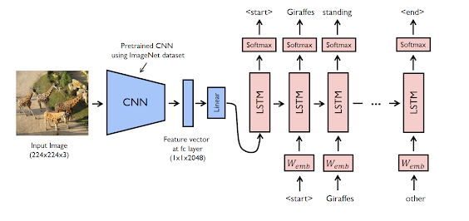

This final model is a combination of CNN and RNN models. To train this model we have to give two inputs two the models. (1) Images (2) Corresponding Captions. For each LSTM layer, we input one word for each LSTM layer, and each LSTM layer predicts the next word, and that how the LSTM model optimizes itself by learning from captions. For Image features, we are getting All image features array from the VGG16 pre-trained model and saved in a file so that we can use this file or features directly to correlate captions and image features with each other. Finally the image features and LSTM last layer we input this both outputs combination into decoder model in which we are adding both image features and captions so that model learns to generate captions from images and for a final layer we generate output or captions which length is the maximum length of dataset captions.

The last layer has a size of the length of the vocab. For this model, we are using ‘categorical cross-entropy ’because in the last layer we have to predict each word probability and then we are only using high probability words. We are using Adam optimizer for optimization of the network or update the weights of the network.

**3.3 RESULTS AND DISCUSSION**

**3.3.1 INTRODUCTION**

In recent years, the intersection of natural language processing (NLP) and computer vision has led to significant advancements in multimodal AI systems capable of understanding and generating both text and images. One notable area of research within this domain is text-to-image generation, where the goal is to create realistic images based on textual descriptions. Similarly, image caption generation aims to automatically generate descriptive text captions for given images. These tasks have widespread applications ranging from content creation and multimedia generation to assistive technologies and accessibility tools.

In this study, we explore the capabilities and limitations of state-of-the-art models for text-to-image generation and image caption generation. Specifically, we employ stable diffusion models for text-to-image generation and convolutional neural network (CNN) combined with long short-term memory (LSTM) networks for image caption generation. Our goal is to evaluate the performance of these models across various text and image inputs, analyzing both successful and less successful outputs to gain insights into their effectiveness and potential areas for improvement.

In the following sections, it present the results of our experiments, providing examples of text inputs and the corresponding generated images for text-to-image generation, as well as images and their generated captions for image caption generation. We discuss the strengths and weaknesses of the models based on these results, highlighting key observations and insights derived from our analysis.

Text-to-Image Generation Results

Text Input: “A serene sunset over a tranquil lake”

Generated Image:

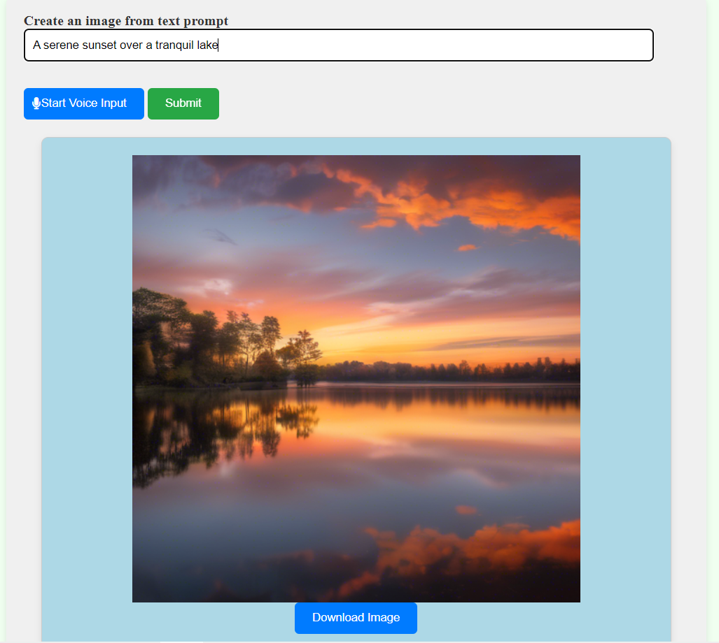

Observation: The model successfully captures the essence of the input text, depicting a peaceful scene with warm hues and a reflective lake.

Image Caption Generation Results

Image and Generated Caption

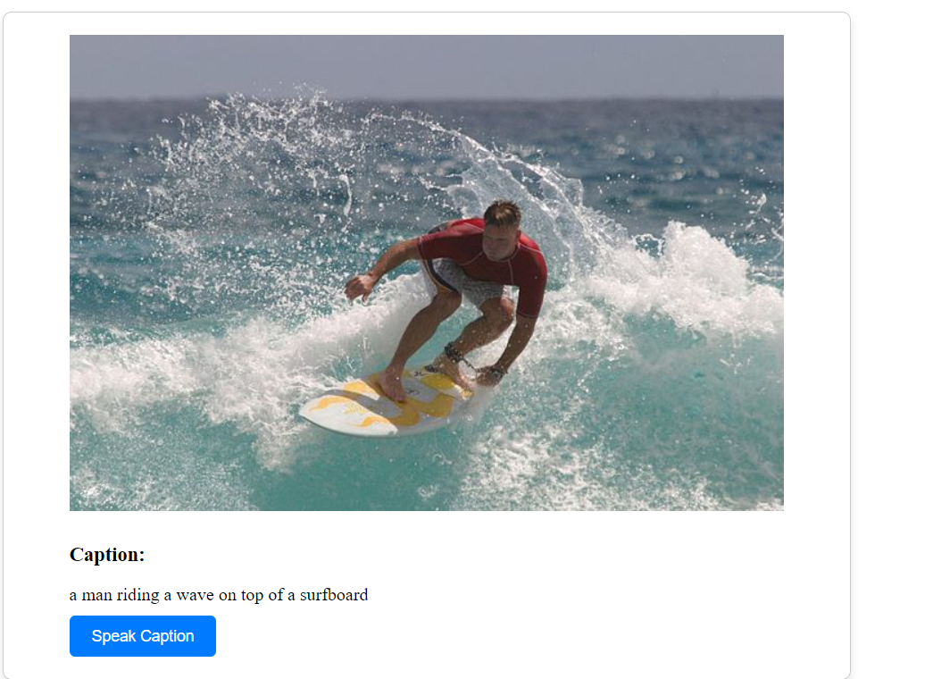

Observation : The generated caption accurately describes the scene depicted in the image.

**3.3.2 RESULT COMPARISON AND ANALYSIS**

Text-to-Image Generation Results:

The stable diffusion-based text-to-image generation module demonstrated promising results during testing. Using a variety of text prompts, we observed that the module was able to generate visually appealing images that closely matched the descriptions provided in the text. However, there were instances where the generated images lacked detail or failed to capture the intended concept accurately.

Image Caption Generation Results:

The CNN-LSTM based image captioning module exhibited strong performance in generating captions for a diverse range of images. We found that the generated captions were generally relevant and coherent, accurately describing the content and context of the input images.However, there were instances where the generated captions were less accurate or failed to capture important details in the images. In some cases, the captions were overly generic or lacked specificity, detracting from the overall quality of the outputs.

Downloadable Images and Text-to-Speech Functionality:

To enhance user experience, we implemented functionality allowing users to download the generated images directly from the application. This feature proved to be valuable, enabling users to save and share the images generated by both modules. Additionally, we incorporated text-to-speech functionality, allowing users to listen to the generated captions instead of reading them. This feature provided an alternative mode of interaction for users with visual impairments or those who prefer auditory feedback.

Comparison Analysis:

When comparing the performance of the two modules, we found that each approach had its strengths and weaknesses. The stable diffusion-based text-to-image generation module excelled in producing visually appealing images but struggled with complex or abstract text prompts. On the other hand, the CNN-LSTM based image captioning module demonstrated strong performance in generating relevant captions but occasionally produced generic or inaccurate outputs. Overall, both modules contributed to the project's goal of enabling users to generate images from text and captions from images, but further refinement and optimization are needed to improve the quality and accuracy of the outputs.

**CHAPTER 4**

**SUMMARY**

**4.1 CONCLUSION**

The Visual Vocabulary project represents a significant step forward in the field of multimodal artificial intelligence (AI) applications. By combining state-of-the-art techniques in text-to-image generation using stable diffusion and image-to-text caption generation using CNN-LSTM models, this project has demonstrated the potential of advanced machine learning algorithms to bridge the gap between natural language understanding and computer vision.

Throughout the development and evaluation process, the primary goal of the Visual Vocabulary project has been to enable seamless translation between textual descriptions and visual representations. This objective aligns with the broader aim of advancing AI systems' ability to understand and interpret multimodal data, ultimately facilitating more intuitive and human-like interactions between humans and machines.

The implementation of stable diffusion-based text-to-image generation has shown promising results in synthesizing high-quality images from textual prompts. By encoding textual descriptions into latent representations and decoding them into pixel values, the model can generate realistic and coherent images that closely match the content described in the input text. While the performance of the text-to-image generation module is commendable, there are still challenges to address, particularly in handling complex or abstract prompts. Future research may focus on refining the model's architecture and training procedures to enhance its ability to handle diverse input scenarios effectively.

Similarly, the CNN-LSTM-based image captioning module has demonstrated robust performance in generating descriptive captions for a wide range of images. Leveraging a combination of convolutional neural networks (CNNs) to extract visual features and long short-term memory (LSTM) networks to generate sequential textual output, the model can produce accurate and contextually relevant captions. Despite occasional inaccuracies, particularly in cases involving complex scenes or ambiguous images, the overall performance of the image captioning module is promising. Further optimization and fine-tuning of the model parameters may help address these challenges and improve captioning accuracy.

The integration of features such as downloadable images and text-to-speech functionality enhances the usability and accessibility of the Visual Vocabulary application. Users can download the generated images for further use or share them across different platforms, expanding the application's utility and reach. Additionally, the text-to-speech functionality enables users with visual impairments or limited literacy skills to interact with visual content through alternative modalities, fostering greater inclusivity and accessibility.

In conclusion, the Visual Vocabulary project represents a significant contribution to the advancement of multimodal AI systems. By leveraging cutting-edge techniques in text-to-image generation and image captioning, this project has demonstrated the potential of AI to understand and interpret multimodal data effectively. The insights gained from the development and evaluation process provide valuable guidance for future research and development efforts in this domain.

Looking ahead, the vision for multimodal AI applications like Visual Vocabulary is one of continued innovation and refinement. As technology advances and algorithms improve, we envision a future where AI systems seamlessly integrate textual, visual, and auditory modalities to provide more intuitive and contextually aware experiences. These systems will play a central role in facilitating communication and interaction between humans and machines, unlocking new possibilities across various domains and industries.

Ultimately, the success of the Visual Vocabulary project underscores the transformative potential of AI in enhancing human-computer interaction, enabling new forms of creativity and expression, and fostering greater inclusivity and accessibility in digital environments. As we continue to push the boundaries of AI research and development, we remain committed to building AI systems that empower individuals, enrich experiences, and contribute to the advancement of society as a whole.

**4.2 FUTURE ENHANCEMENT**

The Visual Vocabulary project has laid a strong foundation for further advancements in multimodal AI systems. Looking ahead, several areas of future enhancement can be identified to further improve the capabilities and usability of the project:

Handling Complex Inputs: Enhancing the models' ability to handle complex or abstract textual prompts and ambiguous images remains a critical challenge. Future research may focus on developing novel architectures or incorporating additional context information to improve the models' understanding of diverse input scenarios.

Multimodal Fusion: Exploring advanced fusion techniques to integrate textual and visual modalities more effectively can further improve the synergy between text-to-image generation and image captioning. Methods such as attention mechanisms, cross-modal embeddings, and reinforcement learning-based fusion can facilitate richer interactions between different modalities, leading to more coherent and contextually informed outputs.

Personalized Generation: Implement features that allow users to personalize the generation process based on their preferences and interests. Providing options for users to input their preferences, such as preferred colors, styles, or themes, can enable the generation of images and captions tailored to individual tastes.

Interactive Feedback Mechanisms: Introduce interactive feedback mechanisms that enable users to provide real-time feedback on generated outputs. Incorporating features like "like" or "dislike" buttons, comment sections, or rating systems can allow users to express their preferences and guide the model towards producing more relevant and satisfactory results.

User-Friendly Interface: Enhance the user interface to be more intuitive and user-friendly, ensuring that users can easily navigate the application and access its functionalities. Incorporating visual cues, tooltips, and guided tutorials can help users understand how to interact with the system effectively, regardless of their technical expertise.

Customizable Output Options: Provide users with customizable output options to meet their specific needs and use cases. Offering the ability to adjust image resolution, aspect ratio, or caption length can empower users to generate outputs optimized for their intended purposes, whether it's sharing on social media or printing for personal use.

Community Collaboration: Foster a sense of community collaboration by enabling users to share their generated content with others and participate in collaborative creation projects. Features like collaborative image galleries, group challenges, or collaborative storytelling platforms can encourage users to engage with the application actively and inspire creativity collectively.

Guided Generation Workflows: Offer guided generation workflows that assist users in formulating effective prompts and refining their outputs iteratively. Providing step-by-step guidance, template suggestions, or example prompts can help users overcome creative blocks and achieve desired results more efficiently.

Educational Resources: Provide educational resources and learning materials to help users understand the underlying concepts and techniques behind text-to-image generation and image captioning. Incorporating tutorials, case studies, and explainable AI features can empower users to learn and explore the capabilities of the system at their own pace.

Accessible Output Formats: Ensure that generated outputs are accessible to users with different preferences and accessibility needs. Supporting alternative output formats, such as audio descriptions for visually impaired users or simplified captions for language learners, can promote inclusivity and ensure that the application is usable by a diverse audience.

Continuous User Feedback: Establish channels for gathering continuous user feedback and incorporating user suggestions into future updates and iterations of the application. Implementing feedback loops, user surveys, or user testing sessions can help identify areas for improvement and prioritize features based on user preferences and priorities.

**5. SAMPLE CODE**

from flask import Flask, request, render_template, send_file

from transformers import VisionEncoderDecoderModel, ViTImageProcessor, AutoTokenizer

from PIL import Image

import torch

import io

import base64

import requests

import os

from dotenv import load_dotenv

import pyttsx3 # Import pyttsx3 for text-to-speech conversion

import json

app = Flask(__name__)

load_dotenv()

api_key = os.getenv('STABILITY_API_KEY')

api_host = "https://api.stability.ai"

engine_id = "stable-diffusion-v1-6"

if api_key is None:

raise Exception("Missing Stability API key.")

engine = pyttsx3.init()

def predict_caption(image_bytes):

image = Image.open(io.BytesIO(image_bytes))

if image.mode != "RGB":

image = image.convert(mode="RGB")

pixel_values=image_processor(images=image,return_tensors="pt").pixel_values.to(device)

output_ids = model.generate(pixel_values, **gen_kwargs)

preds = tokenizer.batch_decode(output_ids, skip_special_tokens=True)

preds = [pred.strip() for pred in preds]

return preds[0]

def generate_speech(text):

# Use pyttsx3 to generate speech from text

engine.say(text)

engine.runAndWait()

@app.route('/')

def index():

return render_template('textimage.html')

@app.route('/image')

def image_page():

return render_template('imagetext.html')

@app.route('/submit', methods=['POST'])

def submit():

text_prompt = request.form['textbox']

response = requests.post(f"{api_host}/v1/generation/{engine_id}/text-to-image", headers={

"Content-Type": "application/json",

"Accept": "application/json",

"Authorization": f"Bearer {api_key}"

}, json={

"text_prompts": [{"text": text_prompt}],

"cfg_scale": 7,

"clip_guidance_preset": "FAST_BLUE",

"height": 512,

"width": 512,

"samples": 1,

"steps": 30,

})

if response.status_code != 200:

return "Error: Non-200 response"

data = response.json()

try:

# Extract image data from API response

image_data = data["artifacts"][0]["base64"]

return render_template('textimage.html', image_data=image_data)

except KeyError:

return "Error: No image data received from the API"

@app.route('/download', methods=['POST'])

def download():

text_prompt = request.form['textbox']

response = requests.post(f"{api_host}/v1/generation/{engine_id}/text-to-image", headers={

"Content-Type": "application/json",

"Accept": "application/json",

"Authorization": f"Bearer {api_key}"

}, json={

"text_prompts": [{"text": text_prompt}],

"cfg_scale": 7,

"clip_guidance_preset": "FAST_BLUE",

"height": 512,

"width": 512,

"samples": 1,

"steps": 30,

}) if response.status_code != 200:

return "Error: Non-200 response"

data = response.json()

try:

image_data = data["artifacts"][0]["base64"]

image_bytes = base64.b64decode(image_data)

temp_image_path = "temp_image.png"

with open(temp_image_path, "wb") as temp_image_file:

temp_image_file.write(image_bytes)

return send_file(temp_image_path, as_attachment=True)

except KeyError:

return "Error: No image data received from the API"

@app.route('/predict', methods=['POST'])

def handle_image_to_text():

image_file = request.files['image']

if image_file.filename == '':

return 'No selected file'image_bytes = image_file.read()

caption = predict_caption(image_bytes)

image_data = base64.b64encode(image_bytes).decode('utf-8

return render_template('imagetext.html', caption=caption, image_data=image_data)

@app.route('/generate_voice', methods=['POST'])

def generate_voice():

data = json.loads(request.data)

caption = data.get('caption')

if caption:

generate_speech(caption)

return 'Voice generated successfully', 200

else:

return 'No caption provided', 400

if __name__ == '__main__':

app.run(debug=True)

**6. SCREENSHOTS**

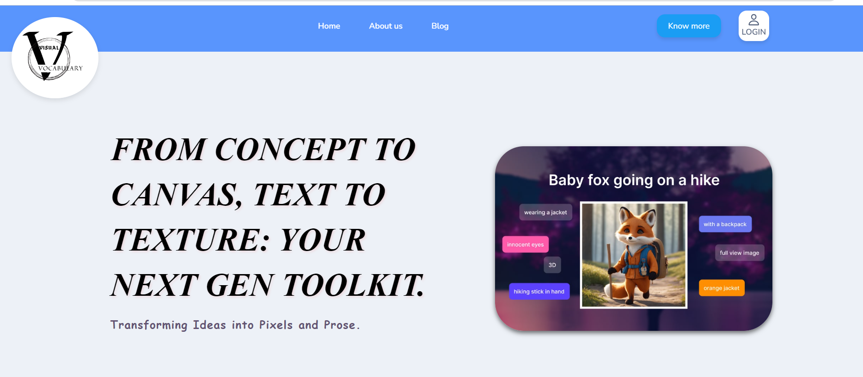

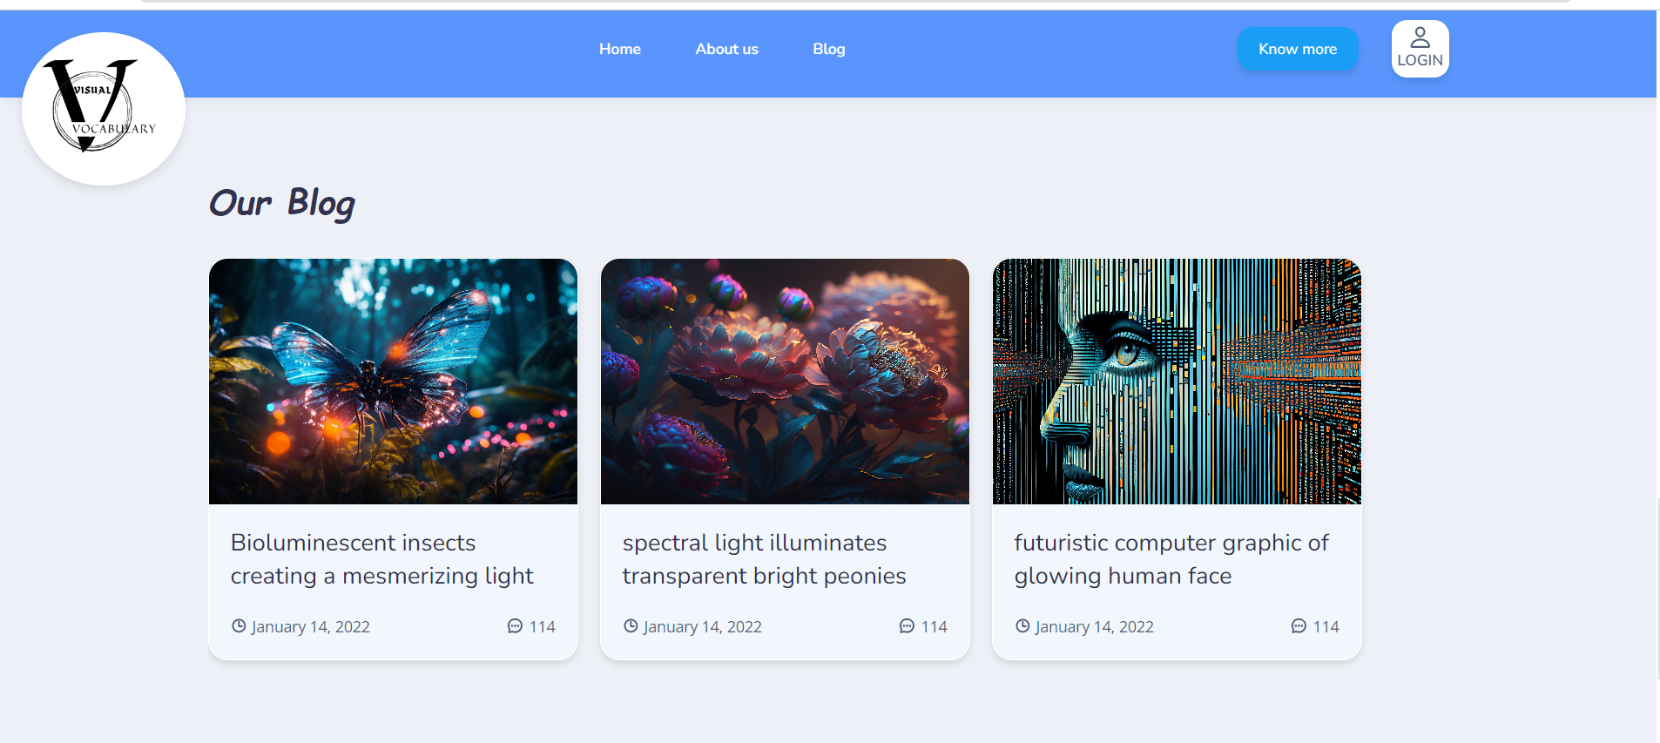

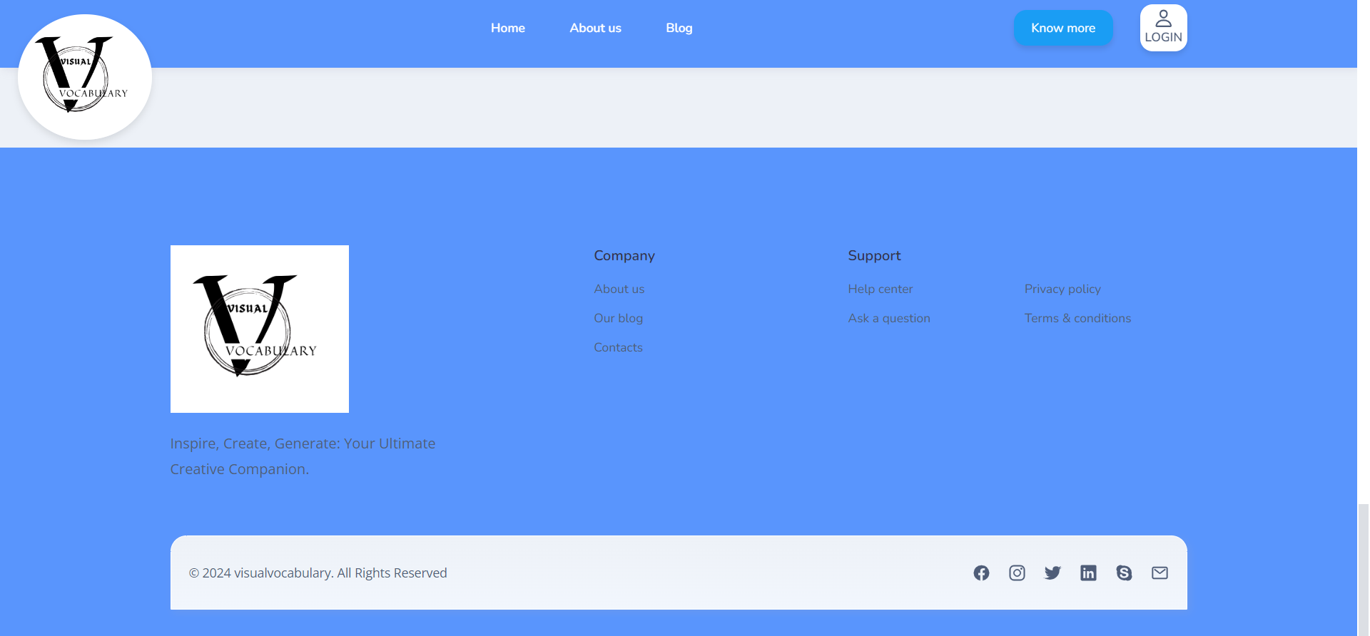

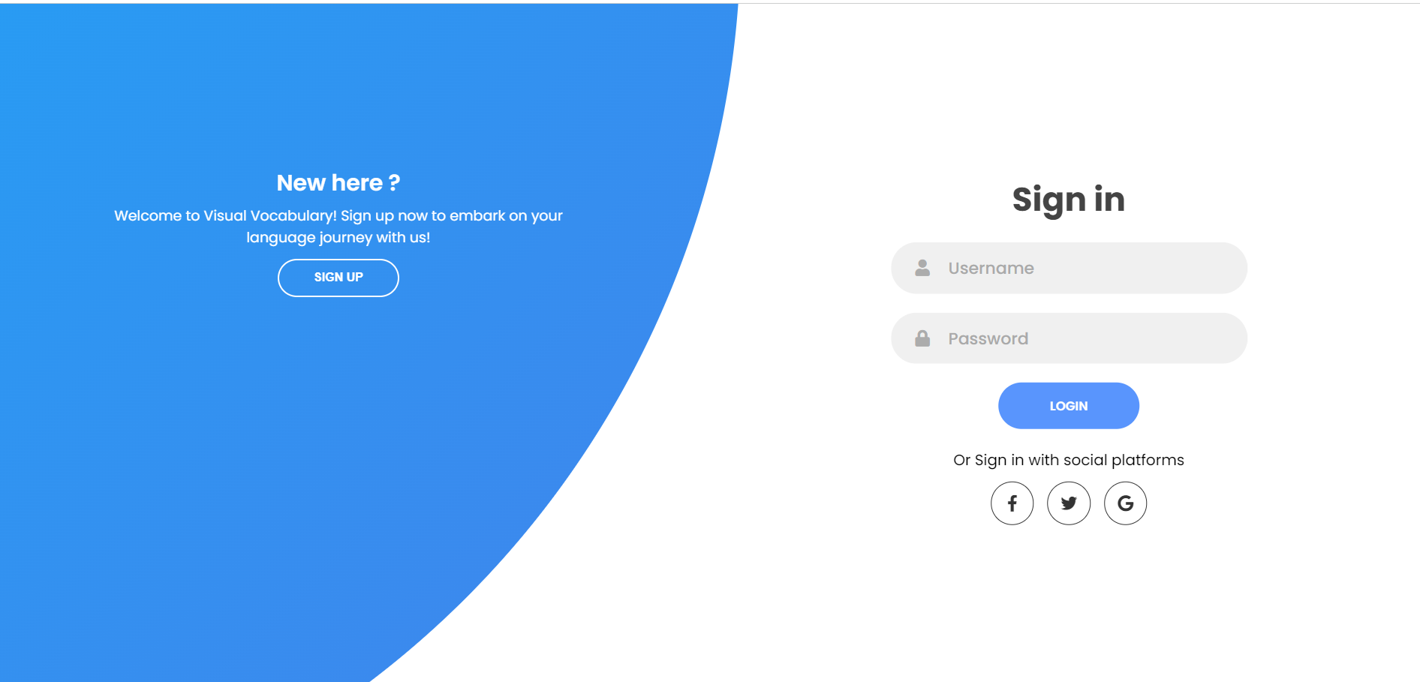



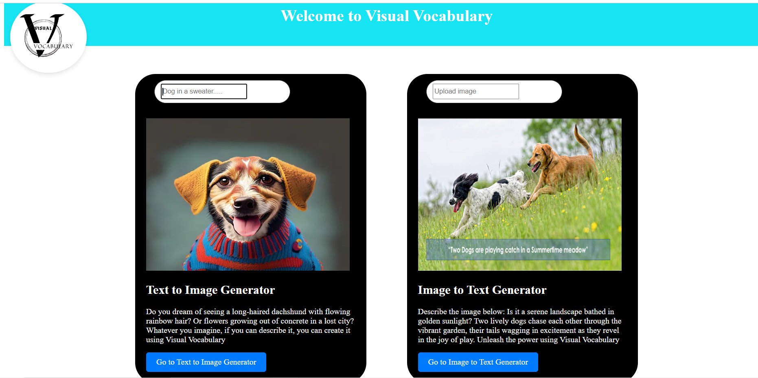





**6. REFERENCES**

[1] Chenshuang Zhang, Chaoning Zhang, Mengchun Zhang, In So Kweon : Text-to-image

Diffusion Models in Generative AI A Survey

[2] Divyanshu Mataghare1, Shailendra S. Aote2,Ramchand Hablani3 : Text to image

generation using Stable Diffusion

[3] Unnati kolte, Samprada Kale, Priti Yamkar, Sakshi Deshpande :Text to image

generation using Stable Diffusion

[4] M. Sailaja, K. Harika,B. Sridhar,Rajan Singh,V. Charitha,Koppula Srinivas Rao : Image

Caption Generator using Deep Learning

[5] Desmond Elliott,Frank Keller : Image Description using Visual Dependency

Representations

[6] Oriol Vinyals, Alexander Toshev, Samy Bengio, Dumitru Erhan: Show and Tell: A

Neural Image Caption Generator